### Exercises 3.4

Many of the datasets from Exercises 3.3 are repeated here so you can use your previous work to help you.

1. A group of diners were asked how much they would pay for a meal. Their responses were: $7.50, $25.00, $10.00, $10.00, $7.50, $8.25, $9.00, $5.00, $15.00, $8.00, $7.25, $7.50, $8.00, $7.00. $12.00.
   1. Using your mean from section 3.3, find the standard deviation of this data. Explain what the mean and standard deviation tell you about how much the group of diners would pay for a meal.
   2. Calculate the five-number summary for this data.
   3. Calculate the range and IQR for this data.
   4. Create a boxplot for the data.
2. ADD The amount of commercials in an hour of television varies by channel. The total length (in minutes) of all commercials from 8 pm to 9 pm in for some selected broadcast and cable channels on a weekday evening were: 10, 12.75, 7, 9, 9.75, 6.5, 12.5, 12.5, 8.75, 17, 10.5, 2
   1. Using your mean from section 3.3, find the standard deviation of this data. Explain what the mean and standard deviation tell you about how much the group of diners would pay for a meal.
   2. Calculate the five-number summary for this data.
   3. Calculate the range and IQR for this data.
   4. Create a boxplot for the data.
3. You recorded the time in seconds it took for 8 participants to solve a puzzle. The times were: 15.2, 18.8, 19.3, 19.7, 20.2, 21.8, 22.1, 29.4.
   1. Using your mean from section 3.3, find the standard deviation of this data. Explain what the mean and standard deviation tell you about how much the group of diners would pay for a meal.
   2. Calculate the five-number summary for this data.
   3. Calculate the range and IQR for this data.
   4. Create a boxplot for the data.
4. ADD You weigh 9 Oreo cookies, and you find the weights (in grams) are: 3.49, 3.51, 3.51, 3.51, 3.52, 3.54, 3.55, 3.58, 3.61
5. Using your mean from section 3.3, find the standard deviation of this data. Explain what the mean and standard deviation tell you about the weights of these Oreo cookies.
6. Calculate the five-number summary for this data.
7. Calculate the range and IQR for this data.
8. Create a boxplot for the data.
9. Use the following table is the cost of purchasing a car at a local dealership.  Some of the cars sold were new and some were used.
10. Find the standard deviation of this data. Explain what the mean and standard deviation tell you about how much the cars are selling for.
11. Calculate the five-number summary for this data.
12. Calculate the range and IQR.
13. Create a boxplot for the data.

|  |  |
| --- | --- |
| Cost  (Thousands of dollars) | Frequency |
| 15 | 3 |
| 20 | 7 |
| 25 | 10 |
| 30 | 15 |
| 35 | 13 |
| 40 | 11 |
| 45 | 9 |
| 50 | 7 |

1. ADD As part of a study of email, a researcher counted the length of 34 emails. The lengths of the emails are shown below, rounded to the nearest thousand characters (so a length 0 means that the numbers of characters rounded to 0, not that the message was blank).

*Data abbreviated from a sample of 50 emails. Data from Advanced High School Statistics, 2nd Ed. (<https://www.openintro.org/stat/textbook.php?stat_book=aps>)

1. Find the standard deviation of this data. Explain what the mean and standard deviation tell you about the length of the emails.
2. Calculate the five-number summary for this data.
3. Calculate the range and IQR.
4. Create a boxplot for the data.

|  |  |
| --- | --- |
| Length of an email (Thousands of characters) | Frequency |
| 0 | 4 |
| 1 | 5 |
| 2 | 2 |
| 3 | 3 |
| 4 | 3 |
| 5 | 1 |
| 6 | 3 |
| 7 | 3 |
| 8 | 0 |
| 9 | 3 |
| 10 | 3 |
| 11 | 2 |
| 12 | 0 |
| 13 | 0 |
| 14 | 2 |

1. Studies are often done by pharmaceutical companies to determine the effectiveness of a treatment. Suppose that a new cancer drug is currently under study. Of interest is the average length of time in months patients live once starting the treatment. Two researchers each follow a different set of 40 cancer patients throughout their treatment. The following data (in months) are collected.
   1. Find the standard deviation of each group.
   2. Calculate the 5-number summary for each group.
   3. Calculate the range and IQR for each group.
   4. Create side-by-side boxplots and compare and contrast the two groups.

Researcher 1: 3, 4, 11, 15, 16, 17, 22, 44, 37, 16, 14, 24, 25, 15, 26, 27, 33, 29, 35, 44, 13, 21, 22, 10, 12, 8, 40, 32, 26, 27, 31, 34, 29, 17, 8, 24, 18, 47, 33, 34

Researcher 2: 3, 14, 11, 5, 16, 17, 28, 41, 31, 18, 14, 14, 26, 25, 21, 22, 31, 2, 35, 44, 23, 21, 21, 16, 12, 18, 41, 22, 16, 25, 33, 34, 29, 13, 18, 24, 23, 42, 33, 29

1. ADD The US Census Bureau, in addition to counting the population of the US every 10 years, conducts yearly informational surveys, such as the American Community Survey (ACS). For the 2012 ACS, a randomly chosen group of 20 respondents (10 males, 10 females) answered a question about their incomes.

Males: $53,000; $70,000; $12,800; 30,000; $4,500; $42,000; $48,000; $60,000; $108,000; $11,000

Females: $1,600; $1,200; $20,000; $25,000; $670; $29,000; $44,000; $30,000; $5,800; $50,000

* 1. Find the standard deviation of each group.
  2. Calculate the 5-number summary for each group.
  3. Calculate the range and IQR for each group.
  4. Create side-by-side boxplots, and compare and contrast the two groups.

*Data from Advanced High School Statistics, 2nd Edition. Section 2.1 # 1 Exercise. (<https://www.openintro.org/stat/textbook.php?stat_book=aps>)

1. An experiment compared the ability of three groups of participants to remember briefly-presented chess positions. The data are shown below. The numbers represent the average number of pieces correctly remembered from three chess positions.
2. Find the standard deviation of each group.
3. Calculate the 5-number summary for each group.
4. Calculate the range and IQR for each group.
5. Create side-by-side boxplots and compare and contrast the three groups.

|  |  |  |
| --- | --- | --- |
| Non-players | Beginners | Tournament Players |
| 22.1 | 32.5 | 40.1 |
| 22.3 | 37.1 | 45.6 |
| 26.2 | 39.1 | 51.2 |
| 29.6 | 40.5 | 56.4 |
| 31.7 | 45.5 | 58.1 |
| 33.5 | 51.3 | 71.1 |
| 38.9 | 52.6 | 74.9 |
| 39.7 | 55.7 | 75.9 |
| 43.2 | 55.9 | 80.3 |
| 43.2 | 57.7 | 85.3 |

1. There is evidence that smiling can attenuate judgments of possible wrongdoing. This phenomenon termed the "smile-leniency effect" was the focus of a study by Marianne LaFrance & Marvin Hecht in 1995[1]. The following data are measurements of how lenient the sentences were for three different types of smiles and one neutral control. The same subject was used for all of the conditions so that may affect the results. The second column is a continuation of the first column.
2. Find the standard deviation for each type of smile and the neutral control.
3. Calculate the 5-number summary for type of smile and the neutral control.
4. Calculate the range and IQR for each type of smile and the neutral control.
5. Create side-by-side boxplots and compare and contrast the four groups.

|  |  |  |  |
| --- | --- | --- | --- |
| False  Smile | Felt Smile | Miserable  Smile | Neutral Control |
| 2.5 | 7 | 5.5 | 2 |
| 5.5 | 3 | 4 | 4 |
| 6.5 | 6 | 4 | 4 |
| 3.5 | 4.5 | 5 | 3 |
| 3 | 3.5 | 6 | 6 |
| 3.5 | 4 | 3.5 | 4.5 |
| 6 | 3 | 3.5 | 2 |
| 5 | 3 | 3.5 | 6 |
| 4 | 3.5 | 4 | 3 |
| 4.5 | 4.5 | 5.5 | 3 |
| 5 | 7 | 5.5 | 4.5 |
| 5.5 | 5 | 4.5 | 8 |
| 3.5 | 5 | 2.5 | 4 |
| 6 | 7.5 | 5.5 | 5 |
| 6.5 | 2.5 | 4.5 | 3.5 |
| 3 | 5 | 3 | 4.5 |
| 8 | 5.5 | 3.5 | 6.5 |
| 6.5 | 5.5 | 8 | 3.5 |
| 8 | 5 | 5 | 4.5 |
| 6 | 4 | 7.5 | 4.5 |
| 6 | 5 | 8 | 2.5 |
| 3 | 6.5 | 4 | 2.5 |
| 7 | 6.5 | 5.5 | 4.5 |
| 8 | 7 | 6.5 | 2.5 |
| 4 | 3.5 | 5 | 6 |
| 3 | 5 | 4 | 6 |
| 2.5 | 3.5 | 3 | 2 |
| 8 | 9 | 5 | 4 |
| 4.5 | 2.5 | 4 | 5.5 |
| 5.5 | 8.5 | 4 | 4 |
| 7.5 | 3.5 | 6 | 2.5 |
| 6 | 4.5 | 8 | 2.5 |
| 9 | 3.5 | 4.5 | 3 |
| 6.5 | 4.5 | 5.5 | 6.5 |

1. Make up two data sets with 5 numbers each that have:
   1. The same mean but different standard deviations.
   2. The same standard deviation but different means.
2. ADD Make up two data sets with 7 numbers that each have:
3. The same IQR but different medians.
4. Different IQRs but the same medians.
5. The side-by-side boxplots show salaries for actuaries and CPAs.
   1. Estimate the 25th, 50th and 75th percentiles for CPA and actuary salaries.
   2. Deshawn makes the median salary for an actuary. Kelsey makes the first quartile salary for a CPA. Who makes more money? How much more?
   3. What percentage of actuaries make more than the median salary of a CPA?
   4. What percentage of CPAs earn less than all actuaries?

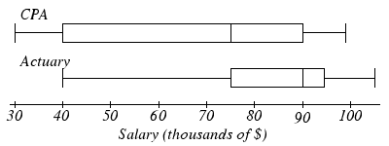

1. ADD Fifty juniors and fifty seniors at a local high school were surveyed to find out how many hours per week they spend studying. The side-by-side boxplots the weekly study times for those high school juniors and seniors.

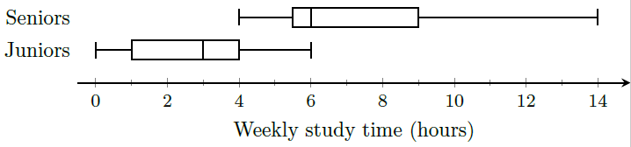

1. Estimate the 25th, 50th, and 75th percentiles for weekly study time for high school juniors and seniors.
2. Olivia studies the maximum number of weekly study hours for a junior. Lucy studies the first quartile weekly study time for a senior. Who studies more, and by how many hours?
3. What percentage of juniors study between the minimum and median weekly study times for seniors?
4. What percentage of seniors study more than the third quartile weekly study time for juniors?
5. Suppose you buy a new car whose advertised gas mileage is 25 mpg (miles per gallon). After driving the car for several months, you find that you are getting only 21.4 mpg. You phone the manufacturer and learn that the standard deviation of gas mileage for cars of that model is 1.15 mpg.
   1. Find the Z-score for the gas mileage of your car.
   2. Does it appear that your car is getting unusually low gas mileage?Explain your answer using your Z-score.
6. ADD According to a local marathon club, the mean finishing time for a marathon is 274 minutes, with a standard deviation of 63 minutes.
   1. If I can run a marathon with a finishing time of 170 minutes, find the Z-score for my marathon time.
   2. Is my marathon finishing time of 170 minutes unusually fast? Explain your answer using the Z-score.
7. This data is a sample of the average number of hours per year that a driver is delayed by road congestion in 11 cities: 56, 53, 53, 50, 46, 45, 44, 43, 42,40, 36
8. Find the mean and the standard deviation, including units.
9. What is the Z-score for the city with an average delay time of 42 hours per year?
10. ADD In a survey of 12 companies recruiting for recent college graduates, they reported the following numbers of job applicants per job posting: 123, 123, 134, 127, 115, 122, 125, 101, 130, 143, 110, and 122.
11. Find the mean and standard deviation, including units.
12. What is the Z score for the company with 143 job applicants per job posting?
13. You scored an 89 on a math test where the class mean and standard deviation are 75 points and 7 points respectively. You scored a 65 on an English test where the mean and standard deviation are 53 points and 4 points, respectively. In which class did you do better? Explain your answer using Z-scores.
14. ADD The mean running time for comedy movies is 139 minutes, with a standard deviation of 39.7 minutes. For action movies, the mean running time is 159 minutes, with a standard deviation of 26.2 minutes. A recent comedy movie had a running time of 102 minutes, while an action movie playing at the same theatre had a running time of 129 minutes. Which movie is shorter compared to other movies in the same genre? Explain your answer using Z-scores.
15. Poe, the Clydesdale horse has a world record breaking height of 20.2 hands. All Clydesdale horses have a mean height of 16.5 hands and a standard deviation of 1.85 hands. The last Great Dane to hold the world record for dog height was Gibson who was 107 cm tall. Great Danes have a mean height of 81 cm and a standard deviation of 13 cm. Which animal is taller compared to their respective breed? Explain your answer using Z-scores.

### Solutions for 3.4 Exercises

**1a.**

In Excel:

I entered the data values into cells A1 through A15.

$=stdev.s\left(A1:A15\right)$

$=\$4.82$

From section 3.3, the mean is $9.80. There are 15 data values, so $n=15.$

We will make a table of data values, their deviations from the mean, and the squared deviations:

|  |  |  |
| --- | --- | --- |
| **Data Value** | **Deviation** | **Deviation Squared** |
| 7.5 | 7.5 - 9.8 = -2.3 | (-2.3)^2 = 5.29 |
| 25 | 25 - 9.8 = 15.2 | (15.2)^2 = 231.04 |
| 10 | 10 - 9.8 = 0.2 | (0.2)^2 = 0.04 |
| 10 | 10 - 9.8 = 0.2 | (0.2)^2 = 0.04 |
| 7.5 | 7.5 - 9.8 = -2.3 | (-2.3)^2 = 5.29 |
| 8.25 | 8.25 - 9.8 = -1.55 | (-1.55)^2 = 2.4 |
| 9 | 9 - 9.8 = -0.8 | (-0.8)^2 = 0.64 |
| 5 | 5 - 9.8 = -4.8 | (-4.8)^2 = 23.04 |
| 15 | 15 - 9.8 = 5.2 | (5.2)^2 = 27.04 |
| 8 | 8 - 9.8 = -1.8 | (-1.8)^2 = 3.24 |
| 7.25 | 7.25 - 9.8 = -2.55 | (-2.55)^2 = 6.5 |
| 7.5 | 7.5 - 9.8 = -2.3 | (-2.3)^2 = 5.29 |
| 8 | 8 - 9.8 = -1.8 | (-1.8)^2 = 3.24 |
| 7 | 7 - 9.8 = -2.8 | (-2.8)^2 = 7.84 |
| 12 | 12 - 9.8 = 2.2 | (2.2)^2 = 4.84 |

Next, we add the squared deviations and get 5.29 + 231.04 + 0.04 + 0.04 + 5.29 + 2.4 + 0.64 + 23.04 + 27.04 + 3.24 + 6.5 + 5.29 + 3.24 + 7.84 + 4.84 = 325.78 dollars-squared.

The sample standard deviation is

$$s=\sqrt{\frac{325.78}{14}}$$

$$=\$4.82$$

**1b.**

In GeoGebra:

In GeoGebra Classic, enter the data values into the column A of the spreadsheet and use the “One Variable Analysis” function. Then use the “Show Statistics” option to find the five-number summary:

|  |  |  |  |  |
| --- | --- | --- | --- | --- |
| Min | $$Q_{1}$$ | Median | $$Q_{3}$$ | Max |
| $5 | $7.50 | $8 | $10 | $25 |

From section 3.3, the data listed in order is:

$5.00, $7.00, $7.25, $7.50, $7.50, $7.50, $8.00, $8.00, $8.25, $9.00, $10.00, $10.00, $12.00, $15.00, $25.00

Also from section 3.3, there are 15 data values ($n=15$), and the median is $8.00.

The lower half of the data is:

$5.00, $7.00, $7.25, $7.50, $7.50, $7.50, $8.00

The median of the lower half is $7.50, so the lower quartile $Q_{1}$ is $7.50.

The upper half of the data is:

$8.25, $9.00, $10.00, $10.00, $12.00, $15.00, $25.00

The median of the upper half is $10.00, so the upper quartile $Q_{3}$ is $10.00.

The smallest and largest data values are $5.00 and 25.00, respectively, so the min and max are $5.00 and $25.00. The five-number summary is:

|  |  |  |  |  |
| --- | --- | --- | --- | --- |
| Min | $$Q_{1}$$ | Median | $$Q_{3}$$ | Max |
| $5 | $7.50 | $8 | $10 | $25 |

**1c.**

The range is:

$$Range=Max-Min$$

$$=25-5$$

$$=\$20$$

The interquartile range (IQR) is:

$$IQR=Q_{3}-Q_{1}$$

$$=10-7.50$$

$$=\$2.50$$

**1d.**

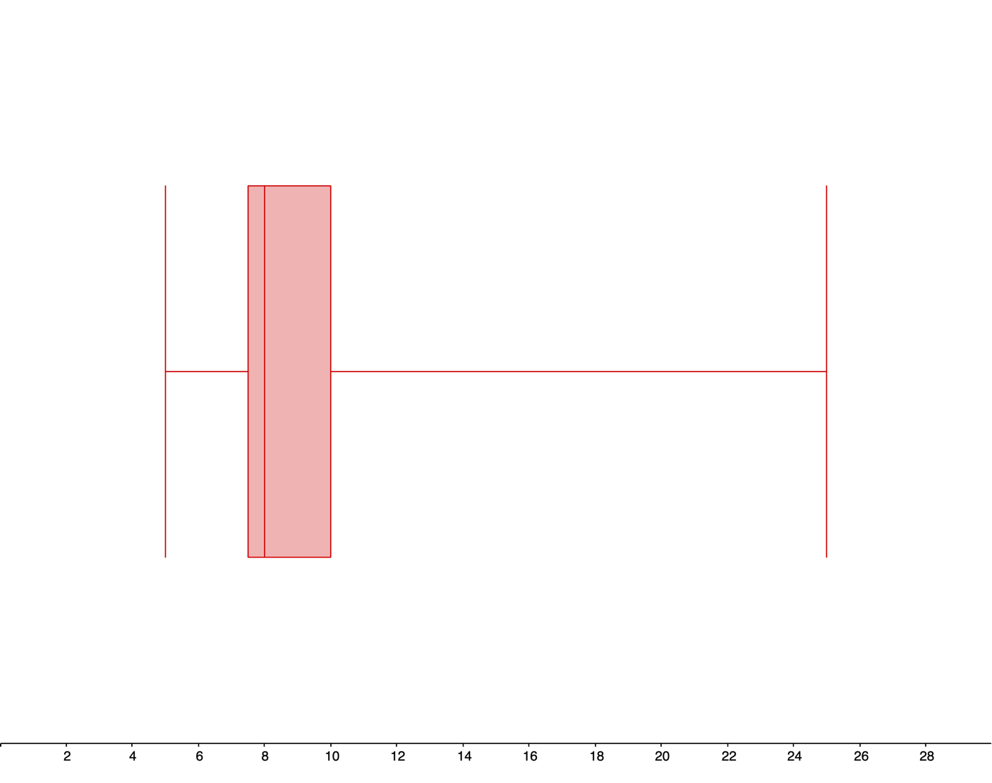

Meal prices (dollars)

**2a.**

In Excel:

I entered the data values into cells A1 through A12.

The standard deviation is:

$=stdev.s\left(A1:A12\right)$

$=3.78 hours$

**2b.**

In GeoGebra:

In GeoGebra Classic, enter the data values into the column A of the spreadsheet and use the “One Variable Analysis” function. Then use the “Show Statistics” option to find the five-number summary:

|  |  |  |  |  |
| --- | --- | --- | --- | --- |
| Min | $$Q_{1}$$ | Median | $$Q_{3}$$ | Max |
| 2 hours | 7.875 hours | 9.875 hours | 12.5 hours | 17 hours |

**2c.**

**The range is:**

$$Range=Max-Min$$

$$=17-2$$

$$=15 hours$$

**The interquartile range (IQR) is:**

$$IQR=Q_{3}-Q_{1}$$

$$=12.5-7.875$$

$$=3.625 hours$$

**2d.**

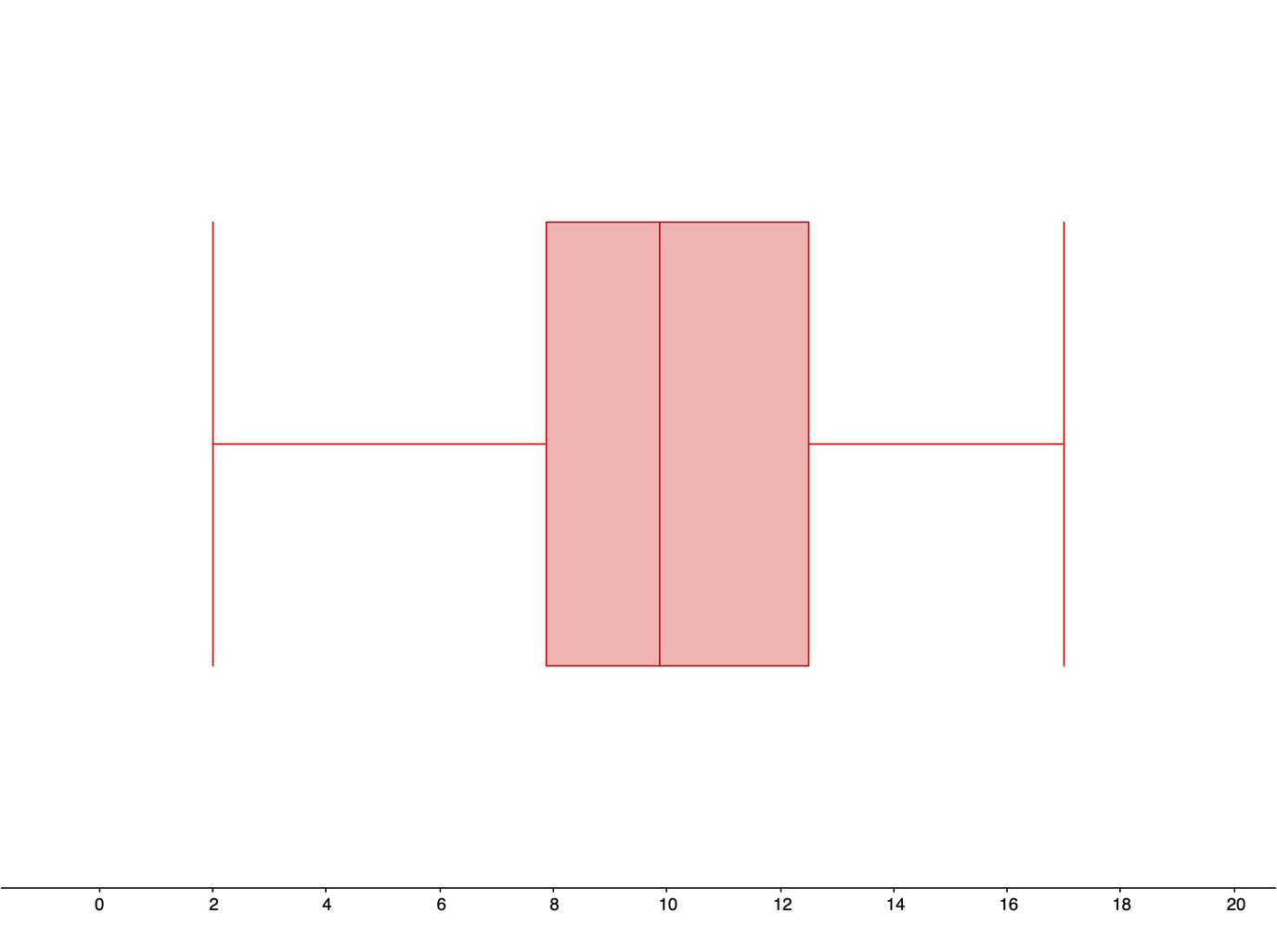

Length of commercials (minutes)

**3a.**

In Excel:

I entered the data values into cells A1 through A12.

The standard deviation is:

$=stdev.s(A1:A12)$

$=4.068$ seconds

**3b.**

In GeoGebra:

In GeoGebra Classic, enter the data values into the column A of the spreadsheet and use the “One Variable Analysis” function. Then use the “Show Statistics” option to find the five-number summary:

|  |  |  |  |  |
| --- | --- | --- | --- | --- |
| Min | $$Q_{1}$$ | Median | $$Q_{3}$$ | Max |
| 15.2 seconds | 19.05 seconds | 19.95 seconds | 21.95 seconds | 29.4 seconds |

**3c.**

The range is:

$$Range=Max-Min$$

$$=29.4-15.2$$

$$=14.2 seconds$$

The interquartile range (IQR) is:

$$IQR=Q_{3}-Q_{1}$$

$$=21.95-19.05$$

$$=2.9 seconds$$

**3d.**

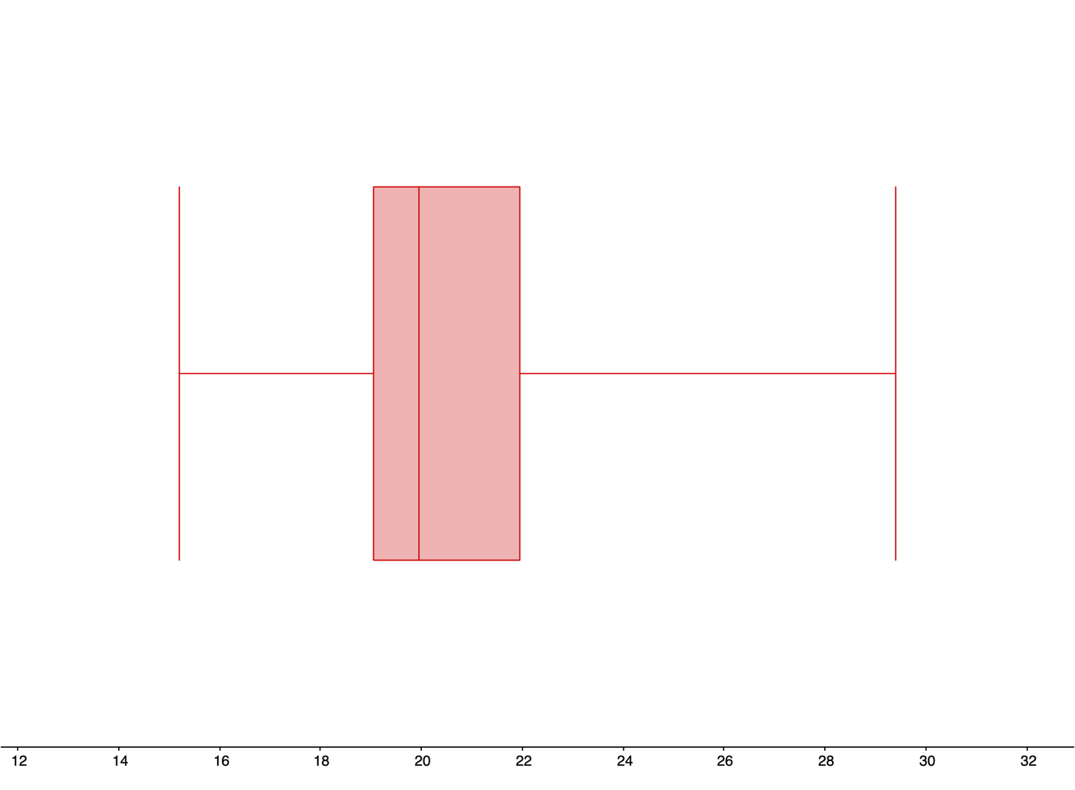

Times to solve a puzzle (seconds)

**4a.**

In Excel:

I entered the data into cells A1 through A9.

The standard deviation is:

$=stdev.s\left(A1:A9\right)$

$=0.039$ grams

**4b.**

In GeoGebra:

In GeoGebra Classic, enter the data values into the column A of the spreadsheet and use the “One Variable Analysis” function. Then use the “Show Statistics” option to find the five-number summary:

|  |  |  |  |  |
| --- | --- | --- | --- | --- |
| Min | $$Q_{1}$$ | Median | $$Q_{3}$$ | Max |
| 3.49 grams | 3.51 grams | 3.52 grams | 3.565 grams | 3.61 grams |

**4c.**

The range is:

$$Range=Max-Min$$

$$=3.61-3.49$$

$$=0.12 grams$$

The interquartile range (IQR) is:

$$IQR=Q_{3}-Q_{1}$$

$$=3.565-3.51$$

$$=0.055 grams$$

**4d.**

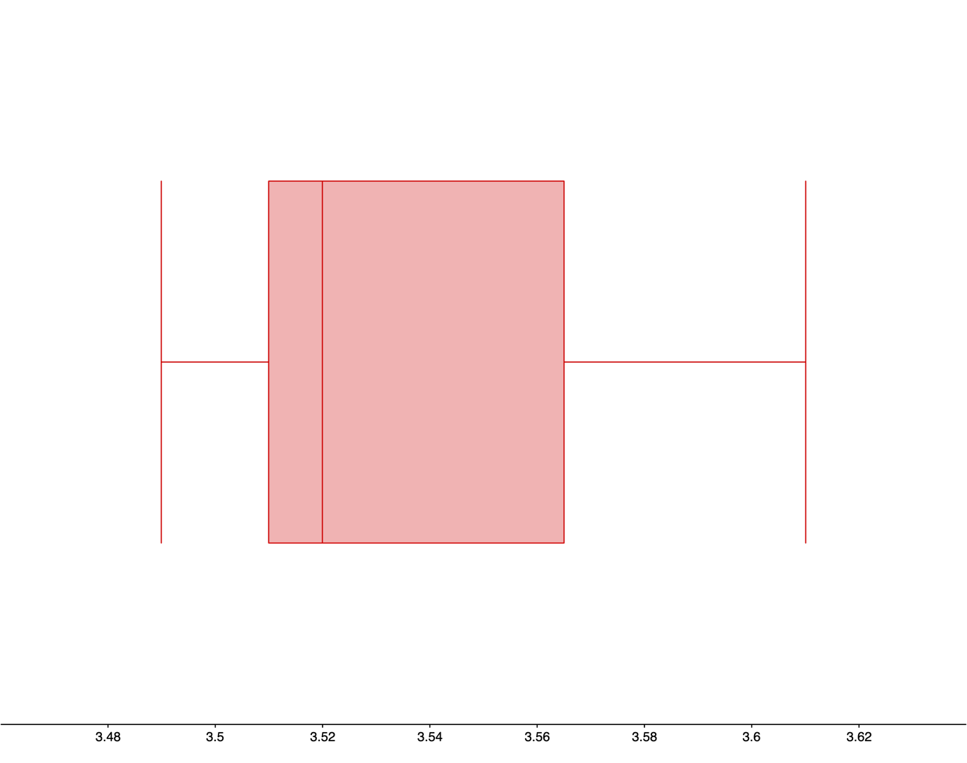

Weights of Oreos (grams)

**5a.**

In GeoGebra:

In GeoGebra Classic, enter the costs into column A and frequencies into column B of the spreadsheet and use the “One Variable Analysis” function. Then use the “Show Statistics” option. The standard deviation is:

$$s=9.58 thousand dollars$$

From section 3.3, the mean is 33.8 thousand dollars.

$$Mean-standard deviation=24.22 thousand dollars$$

$$Mean+standard deviation=43.38 thousand dollars$$

The mean and standard deviation together tell us that most of the cars at the local dealership are selling for between 24.22 and 43.38 thousand dollars.

**5b.**

In GeoGebra:

In GeoGebra Classic, enter the costs into column A and frequencies into column B of the spreadsheet and use the “One Variable Analysis” function. Then use the “Show Statistics” option to find the five-number summary:

|  |  |  |  |  |
| --- | --- | --- | --- | --- |
| Min | $$Q_{1}$$ | Median | $$Q_{3}$$ | Max |
| 15 thousand dollars | 25 thousand dollars | 35 thousand dollars | 40 thousand dollars | 50 thousand dollars |

**5c.**

The range is:

$$Range=Max-Min$$

$$=50-15$$

$$=35 thousand dollars$$

The interquartile range (IQR) is:

$$IQR=Q_{3}-Q_{1}$$

$$=40-15$$

$$=25 thousand dollars$$

**5d.**

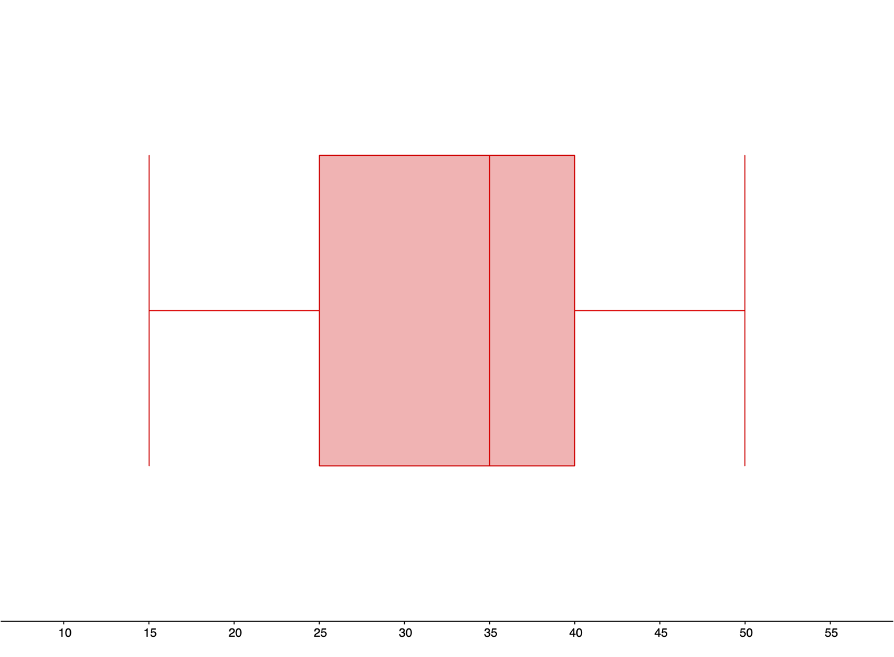

Costs of purchasing a car (thousands of dollars)

**6a.**

In GeoGebra:

In GeoGebra Classic, enter the lengths into column A and frequencies into column B of the spreadsheet and use the “One Variable Analysis” function. Then use the “Show Statistics” option. The standard deviation is:

$$s=4.20 thousand characters$$

From section 3.3, the mean is 5.3 thousand characters.

$$Mean-standard deviation=1.1 thousand characters$$

$$Mean+standard deviation=9.5 thousand characters$$

The mean and standard deviation together tell us that most of the email lengths are between 1.1 and 9.5 thousand characters.

**6b.**

In GeoGebra:

In GeoGebra Classic, enter the lengths into column A and frequencies into column B of the spreadsheet and use the “One Variable Analysis” function. Then use the “Show Statistics” option to find the five-number summary:

|  |  |  |  |  |
| --- | --- | --- | --- | --- |
| Min | $$Q_{1}$$ | Median | $$Q_{3}$$ | Max |
| 0 thousand characters | 1 thousand characters | 4.5 thousand characters | 9 thousand characters | 14 thousand characters |

**6c.**

The range is:

$$Range=Max-Min$$

$$=14-0$$

$$=14 thousand characters$$

The interquartile range (IQR) is:

$$IQR=Q_{3}-Q_{1}$$

$$=9-1$$

$$=8 thousand characters$$

**6d.**

Boxplot of email length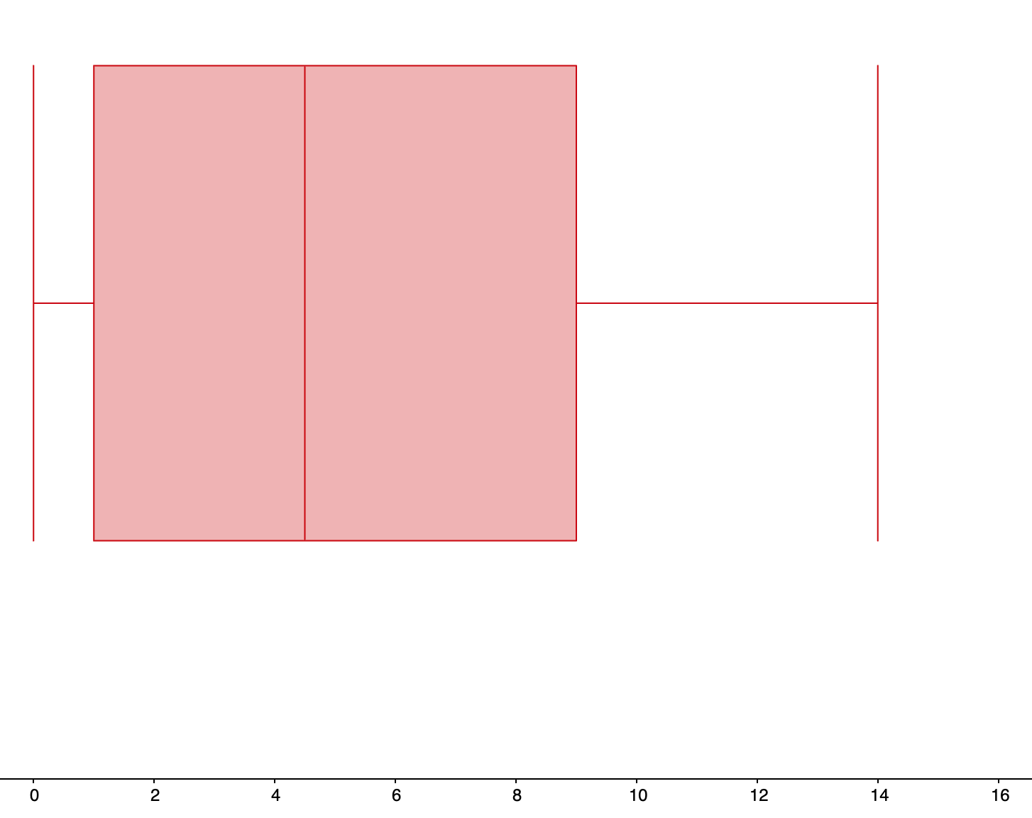

Length (thousands of characters)

**7a.**

In GeoGebra:

In GeoGebra Classic, enter the data values for Researcher 1 into column A of the spreadsheet, and enter the data values for Researcher 2 into column B of the spreadsheet. Then use the “Multiple Variable Analysis” function. Then use the “Show Statistics” function to display the sample standard deviation for each set of data values.

The sample standard deviation for Researcher 1 is 11.25 months. The sample standard deviation for Research 2 is 11.38 months.

**7b.**

In GeoGebra:

In GeoGebra Classic, enter the data values for Researcher 1 into column A of the spreadsheet, and enter the data values for Researcher 2 into column B of the spreadsheet. Then use the “Multiple Variable Analysis” function. Then use the “Show Statistics” function to display the sample standard deviation for each set of data values.

The 5-number summary for Researcher 1 is:

|  |  |  |  |  |
| --- | --- | --- | --- | --- |
| Min | $$Q_{1}$$ | Median | $$Q_{3}$$ | Max |
| 3 months | 15 months | 24 months | 32.5 months | 47 months |

The 5-number summary for Researcher 2 is:

|  |  |  |  |  |
| --- | --- | --- | --- | --- |
| Min | $$Q_{1}$$ | Median | $$Q_{3}$$ | Max |
| 2 months | 16 months | 22 months | 30 months | 44 months |

**7c.**

The range for Researcher 1 is:

$$Range=Max-Min$$

$$=47-3$$

$$=44 months$$

The interquartile range (IQR) for Researcher 1 is:

$$IQR=Q_{3}-Q_{1}$$

$$=32.5-15$$

$$=17.5 months$$

The range for Researcher 2 is:

$$Range=Max-Min$$

$$=44-2$$

$$=42 months$$

The interquartile range (IQR) for Researcher 2 is:

$$IQR=Q_{3}-Q_{1}$$

$$=30-16$$

$$=14 months$$

**7d.**

In GeoGebra Classic, enter the data values for Researcher 1 into column A of the spreadsheet, and enter the data values for Research 2 into column B of the spreadsheet. Then use the “Multiple Variable Analysis” function. Then select “Stacked BoxPlots” from the drop-down menu.

Boxplot of life time after treatment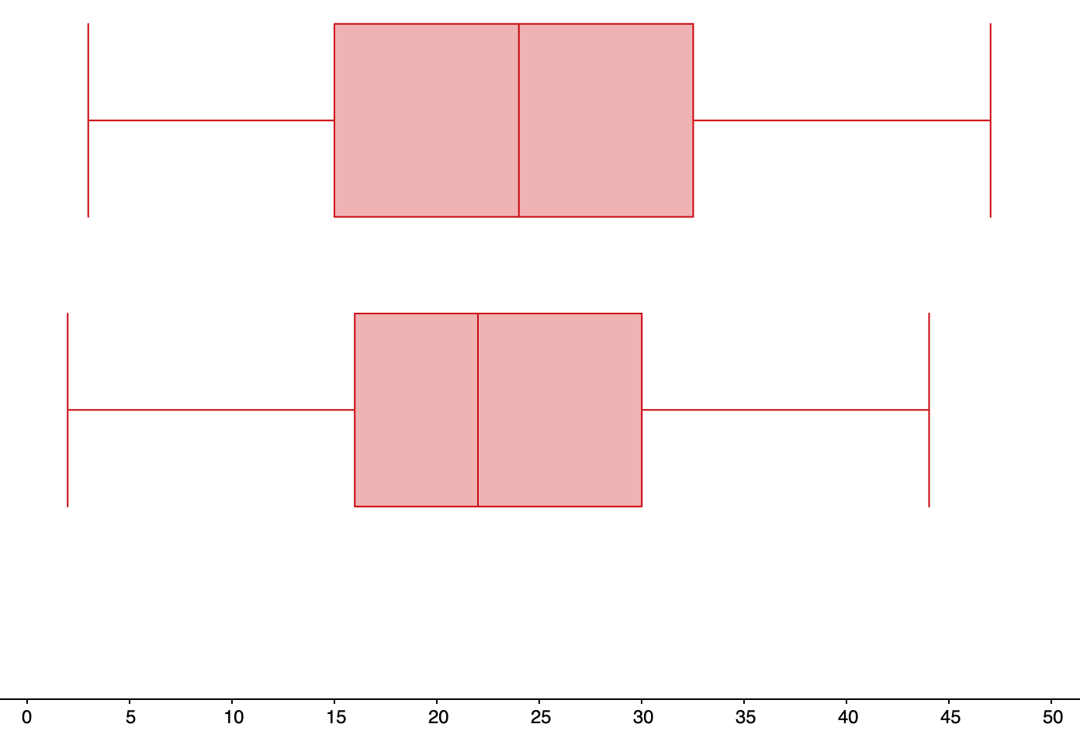

Researcher 2

Researcher 1

Time (months)

Researcher 1 has a larger minimum, median, 3rd quartile, and maximum than Researcher 2. For Researcher 1, 50% of the patients live longer than 24 months after treatment, compared to 50% of patients living longer than 22 months after treatment for Researcher 1.

Researcher 2 has less variation in the life times than Researcher 1, with an IQR of 14 months for Researcher 2, compared to an IQR 16.5 months for Researcher 1.

**8a.**

In GeoGebra:

In GeoGebra Classic, enter the data values for males into column A of the spreadsheet, and enter the data values for females into column B of the spreadsheet. Then use the “Multiple Variable Analysis” function. Then use the “Show Statistics” function to display the sample standard deviation for each set of data values.

The sample standard deviation for males is $31,530.66. The sample standard deviation for females is $18,806.22.

**8b.**

In GeoGebra:

In GeoGebra Classic, enter the data values for males into column A of the spreadsheet, and enter the data values for females into column B of the spreadsheet. Then use the “Multiple Variable Analysis” function. Then use the “Show Statistics” function to display the sample standard deviation for each set of data values.

The 5-number summary for males is:

|  |  |  |  |  |
| --- | --- | --- | --- | --- |
| Min | $$Q_{1}$$ | Median | $$Q_{3}$$ | Max |
| $4,500 | $12,800 | $45,000 | $60,000 | $108,000 |

The 5-number summary for females is:

|  |  |  |  |  |
| --- | --- | --- | --- | --- |
| Min | $$Q_{1}$$ | Median | $$Q_{3}$$ | Max |
| $670 | $1,600 | $22,500 | $30,000 | $50,000 |

**8c.**

The range for males is:

$$Range=Max-Min$$

$$=108,000-4500$$

$$=\$103,500$$

The interquartile range (IQR) for males is:

$$IQR=Q_{3}-Q_{1}$$

$$=60,000-12,800$$

$$=\$47,200$$

The range for females is:

$$Range=Max-Min$$

$$=50,000-670$$

$$=\$49,330$$

The interquartile range (IQR) for females is:

$$IQR=Q_{3}-Q_{1}$$

$$=30,000-1,600$$

$$=\$28,400$$

**8d.**

**Boxplot of incomes for males and females**

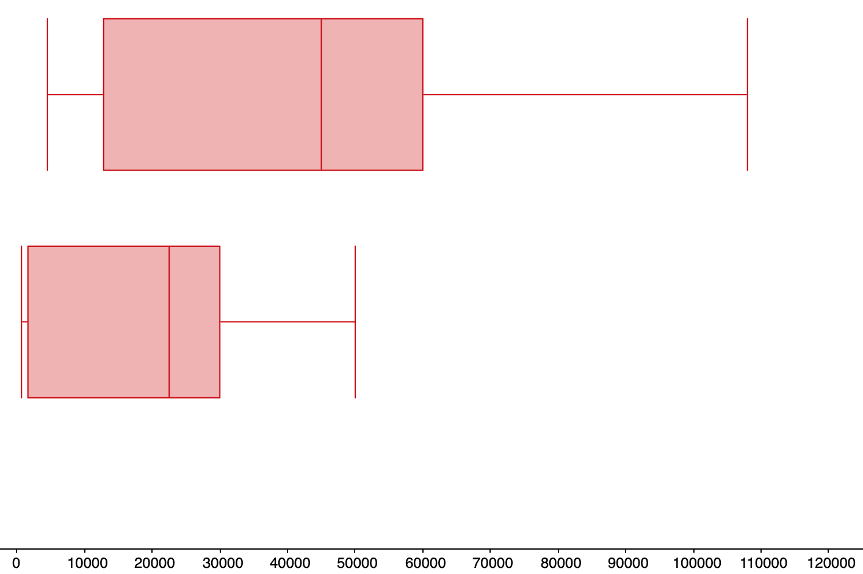

Females

Males

Income (dollars)

All of the values for the males’ 5-number summary are larger than the corresponding values for the females’ 5-number summary. The maximum income for males is more than twice the maximum income for females. Males have a significantly greater amount of variation in incomes than females, as shown by the larger range, IQR and standard deviation for males compared to females.

**9a.**

In GeoGebra:

In GeoGebra Classic, enter the data values for non-players into column A of the spreadsheet, enter the data values for beginners into column B of the spreadsheet, and enter the data value for tournament players into column C of the spreadsheet. Then use the “Multiple Variable Analysis” function. Then use the “Show Statistics” function to display the sample standard deviation for each set of data values.

The sample standard deviation for non-players is 8.033 chess pieces. The sample standard deviation for beginners is 9.031 chess pieces. The sample standard deviation for tournament players is 15.622 chess pieces.

**9b.**

In GeoGebra:

In GeoGebra Classic, enter the data values for non-players into column A of the spreadsheet, enter the data values for beginners into column B of the spreadsheet, and enter the data value for tournament players into column C of the spreadsheet. Then use the “Multiple Variable Analysis” function. Then use the “Show Statistics” function to display the sample standard deviation for each set of data values.

The 5-number summary for non-players is:

|  |  |  |  |  |
| --- | --- | --- | --- | --- |
| Min | $$Q_{1}$$ | Median | $$Q_{3}$$ | Max |
| 22.1 chess pieces | 26.2 chess pieces | 32.6 chess pieces | 39.7 chess pieces | 43.2 chess pieces |

The 5-number summary for beginners is:

|  |  |  |  |  |
| --- | --- | --- | --- | --- |
| Min | $$Q_{1}$$ | Median | $$Q_{3}$$ | Max |
| 32.5 chess pieces | 39.1 chess pieces | 48.4 chess pieces | 55.7 chess pieces | 57.7 chess pieces |

The 5-number summary for tournament players is:

|  |  |  |  |  |
| --- | --- | --- | --- | --- |
| Min | $$Q_{1}$$ | Median | $$Q_{3}$$ | Max |
| 40.1 chess pieces | 51.2 chess pieces | 64.6 chess pieces | 75.9 chess pieces | 85.3 chess pieces |

**9c.**

The range for non-players is:

$$Range=Max-Min$$

$$=43.2-22.1$$

$$=21.1 chess pieces$$

The interquartile range (IQR) for non-players is:

$$IQR=Q_{3}-Q_{1}$$

$$=39.7-26.2$$

$$=13.5 chess pieces$$

The range for beginners is:

$$Range=Max-Min$$

$$=57.7-32.5$$

$$=25.2 chess pieces$$

The interquartile range (IQR) for beginners is:

$$IQR=Q_{3}-Q_{1}$$

$$=55.7-39.1$$

$$=16.6 chess pieces$$

The range for tournament players is:

$$Range=Max-Min$$

$$=85.3-40.1$$

$$=45.2 chess pieces$$

The interquartile range (IQR) for tournament players is:

$$IQR=Q_{3}-Q_{1}$$

$$=75.9-51.2$$

$$=24.7 chess pieces$$

**9d.**

Boxplot of positions remembered by non-players, beginners, and tournament players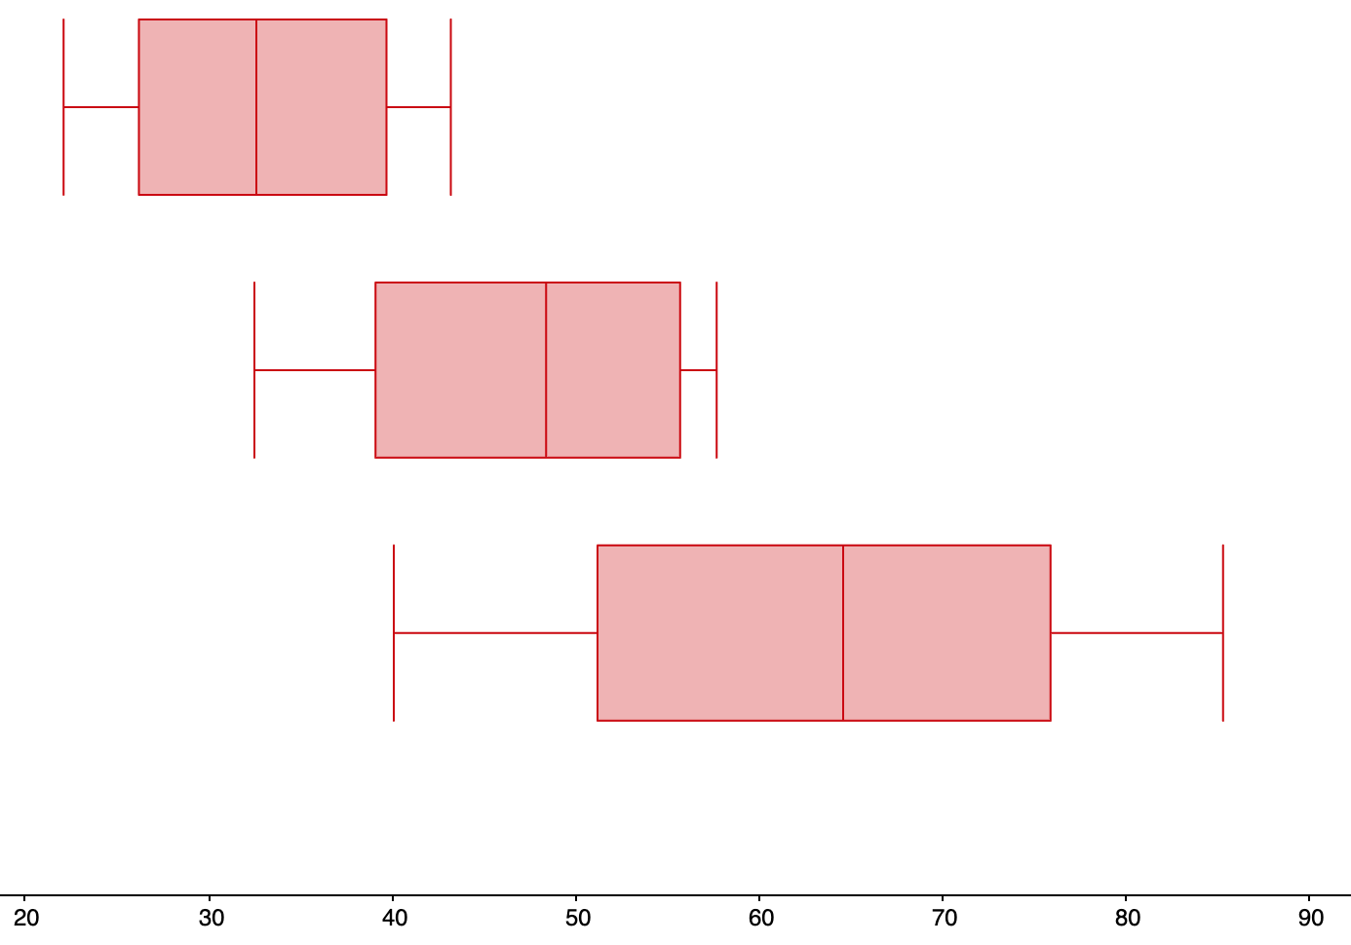

Tournament players

Beginners

Non-players

Tournament players did the best at remembering positions (as shown by all of the numbers of their 5-number summary being larger than the corresponding numbers for the other two groups). However, tournaments players were not completely superior to the other two groups; the best non-players remembered more chess pieces than the worst tournament players. Also tournament players had more variation in how much they.

**10a.**

In GeoGebra:

In GeoGebra Classic, enter the data values for false smile, felt smile, miserable smile, and neutral control into columns A, B, C, and D, respectively, of the spreadsheet. Then use the “Multiple Variable Analysis” function. Then use the “Show Statistics” function to display the sample standard deviation for each set of data values.

The sample standard deviation for the false smile group is 1.827. The sample standard deviation for the felt smile group is 1.681. The sample standard deviation for tournament players is 1.454. The sample standard deviation for the neutral control is 1.523.

**10b.**

In GeoGebra:

In GeoGebra Classic, enter the data values for false smile, felt smile, miserable smile, and neutral control into columns A, B, C, and D, respectively, of the spreadsheet. Then use the “Multiple Variable Analysis” function. Then use the “Show Statistics” function to display the sample standard deviation for each set of data values.

The 5-number summary for the false smile group is:

|  |  |  |  |  |
| --- | --- | --- | --- | --- |
| Min | $$Q_{1}$$ | Median | $$Q_{3}$$ | Max |
| 2.5 | 3.5 | 5.5 | 6.5 | 9 |

The 5-number summary for the felt smile group is:

|  |  |  |  |  |
| --- | --- | --- | --- | --- |
| Min | $$Q_{1}$$ | Median | $$Q_{3}$$ | Max |
| 2.5 | 3.5 | 4.75 | 6 | 9 |

The 5-number summary for the miserable smile group is:

|  |  |  |  |  |
| --- | --- | --- | --- | --- |
| Min | $$Q_{1}$$ | Median | $$Q_{3}$$ | Max |
| 2.5 | 4 | 4.75 | 5.5 | 8 |

The 5-number summary for the neutral control group is:

|  |  |  |  |  |
| --- | --- | --- | --- | --- |
| Min | $$Q_{1}$$ | Median | $$Q_{3}$$ | Max |
| 2 | 3 | 4 | 5 | 8 |

**10c.**

The range for false smile is:

$$Range=Max-Min$$

$$=9-2.5$$

$$=6.5$$

The interquartile range (IQR) for false smile is:

$$IQR=Q_{3}-Q_{1}$$

$$=6.5-3.5$$

$$=3$$

The range for felt smile is:

$$Range=Max-Min$$

$$=9-2.5$$

$$=6.5$$

The interquartile range (IQR) for felt smile is:

$$IQR=Q_{3}-Q_{1}$$

$$=6-3.5$$

$$=2.5$$

The range for miserable smile is:

$$Range=Max-Min$$

$$=85.3-40.1$$

$$=45.2 chess pieces$$

The interquartile range (IQR) for miserable smile is:

$$IQR=Q_{3}-Q_{1}$$

$$=5.5-4$$

$$=1.5$$

The range for neutral control is:

$$Range=Max-Min$$

$$=8-2$$

$$=6$$

The interquartile range (IQR) for neutral control is:

$$IQR=Q_{3}-Q_{1}$$

$$=5-3$$

$$=2$$

**10d.**

Boxplot of leniency by type of smile 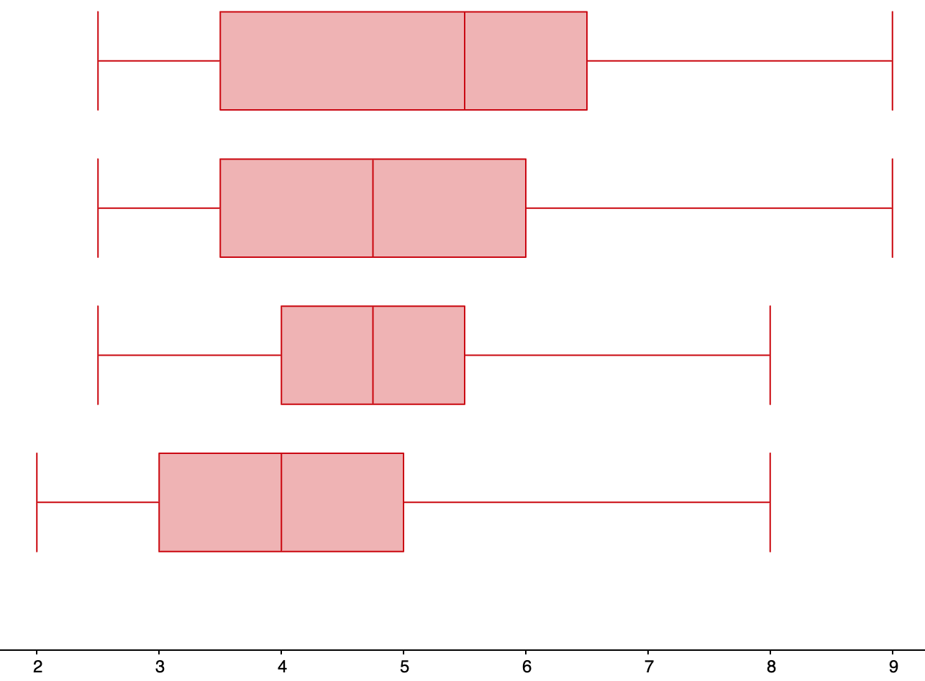

Neutral control

Miserable smile

Felt smile

False smile

Leniency

The minimum and median for all the smile groups was larger than the minimum and median for the neutral control, indicating that a smile has some effect on leniency. The false smile seems to have been the most effective because the minimum, median, 3rd quartile, and maximum for the false group are greater than or equal to the corresponding values for any of the other groups.

**11a.**

There are many possible answers for this question. The data sets {10, 10, 10, 10, 10} and {9, 9, 10, 11, 11} have the same mean (10) but different standard deviations (0 and 1, respectively).

**11b.**

There are many possible answers for this question. The data sets {2, 2, 2, 2, 2} and {9, 9, 9, 9, 9} have the same standard deviation (0) but different means (2 and 9, respectively).

**12a.**

There are many possible answers for this question. The data sets {1, 2, 3, 4, 5, 6, 7} and and {11, 12, 13, 14, 15, 16, 17} have the same IQR (4) but different medians (4 and 14, respectively).

**12b.**

There are many possible answers for this question. The data sets {14, 14, 14, 14, 14, 14, 14} and {1, 1, 1, 14, 26, 26, 26} have the same median (14) but different IQRs (0 and 25, respectively).

**13a.**

The 25th, 50th, and 75th percentiles are, respectively, the 1st quartile, median, and 3rd quartile for the data sets. Reading the boxplot for CPAs, the 25th, 50th, and 75th percentiles for CPAs’ salaries are, respectively, $40,000, $75,000, and $90,000. Reading the boxplot for actuaries, the 25th, 50th, and 75th percentiles for actuaries’ salaries are, respectively, $75,000, $90,000, and $94,000.

**13b.**

Deshawn’s salary (the median salary for an actuary) is $90,000; Kelsey’s salary (the first quartile salary) is also $75,000. So Deshawn makes more than Kelsey, by $15,000.

**13c.**

75% of actuaries make more than the median salary of a CPA ($75,000).

**13d.**

25% of all CPAs earn less than all actuaries.

**14a.**

The 25th, 50th, and 75th percentiles for weekly study times for the juniors are 1 hour, 3 hours, and 4 hours, respectively. The 25th, 50th, and 75th percentiles for weekly study times the seniors are 5.5 hours, 6 hours, and 9 hours.

**14b.**

Olivia studies more each week than Lucy, by 30 minutes.

**14c.**

50% of juniors study between the minimum and median number of hours for seniors.

**14d.**

100% of seniors study more than the third quartile weekly study time for juniors.

**15a.**

$$Z=\frac{data value-mean}{standard deviation} \\ =\frac{21.4-25}{1.15} \\ =-3.13 standard deviations$$

The *z*-score for the gas mileage of the car is $-3.13$ standard deviations.

**15b.**

The *z*-score for the gas mileage of the car is less than $-2$ standard deviations, so yes, it appears that your car is getting unusually low gas mileage.

**16a.**

$$Z=\frac{data value-mean}{standard deviation} \\ =\frac{170-274}{63} \\ =-1.65 standard deviations$$

The marathon time’s *Z*-score is -1.65 standard deviations.

**16b.**

Because the marathon finishing time is within 2 standard deviations of the mean finishing time, no, this marathon finishing time is not usually fast.

**17a.**

In GeoGebra:

In GeoGebra Classic, enter the data values into the column A of the spreadsheet and use the “One Variable Analysis” function. Then use the “Show Statistics” option to find the mean and standard deviation.

The mean is 46.2 hours per year, and the standard deviation is 6.16 hours per year.

**17b.**

$$Z=\frac{data value-mean}{standard deviation} \\ =\frac{42-46.2}{6.16} \\ =-0.68 standard deviations$$

The *Z*-score for a city with an average delay time of 42 hours per year is $-0.68$ standard deviations.

**18a.**

In GeoGebra:

In GeoGebra Classic, enter the data values into the column A of the spreadsheet and use the “One Variable Analysis” function. Then use the “Show Statistics” option to find the mean and standard deviation.

The mean is 122.9 job applicants per job posting, and the standard deviation is 10.91 job applicants per job posting.

**18b.**

$$Z=\frac{data value-mean}{standard deviation} \\ =\frac{143-122.9}{10.91} \\ =1.84 standard deviations$$

The *Z*-score for a company with 143 job applicants per job posting is $1.84$ standard deviations.

**19.**

$$Z_{math}=\frac{data value-mean}{standard deviation} \\ =\frac{89-75}{7} \\ =2 standard deviations$$

$$Z_{English}=\frac{data value-mean}{standard deviation} \\ =\frac{65-53}{4} \\ =3 standard deviations$$

Because the *Z*-score of my English test is greater than the *Z*-score of my math test, I did better on the English test than I did on the math test.

**20.**

$$Z_{comedy}=\frac{data value-mean}{standard deviation} \\ =\frac{102-139}{39.7} \\ = -0.93 standard deviations$$

$$Z_{action}=\frac{data value-mean}{standard deviation} \\ =\frac{129-159}{26.2} \\ = -1.14 standard deviations$$

Because the *Z*-score for the 129 minute action movie was less than the *Z*-score for the 102 comedy movie, the action movie was shorter than the comedy movie, when both movies are compared to other movies in their genres.

**21.**

$$Z_{Poe}=\frac{data value-mean}{standard deviation} \\ =\frac{20.2-16.5}{1.85} \\ = 2 standard deviations$$

$$Z_{Gibson}=\frac{data value-mean}{standard deviation} \\ =\frac{107-81}{13} \\ = 2 standard deviations$$

Because the *Z*-scores for the heights of Poe (the Clydesdale horse) and Gibson (the Great Dane) are the same, neither animal is taller than the other when compared to their respective breeds.

1. LaFrance, M., & Hecht, M. A. (1995) Why smiles generate leniency. Personality and Social Psychology Bulletin, 21, 207-214. Adapted from [www.onlinestatbook.com](http://www.onlinestatbook.com), by David M. Lane, et al, used under [CC-BY-SA 3.0](https://creativecommons.org/licenses/by-sa/3.0/us/).